Health & Fitness Journal Portal

This guide will help to use this Healthfit applications

**Please Note: To Run the application successfully you have to perform all the steps given and HealthFit Installation and Configurations Guide and Your both HealthFit Api and HealthFit Web application is running.**

**Register User (Publisher):**

1. One you run your HealthFit Web application, will be land to Dashboard page and its looks like below, (Make sure you HealthFit Api application is running)
2. 
3. Navigate to Signup Page,
4. 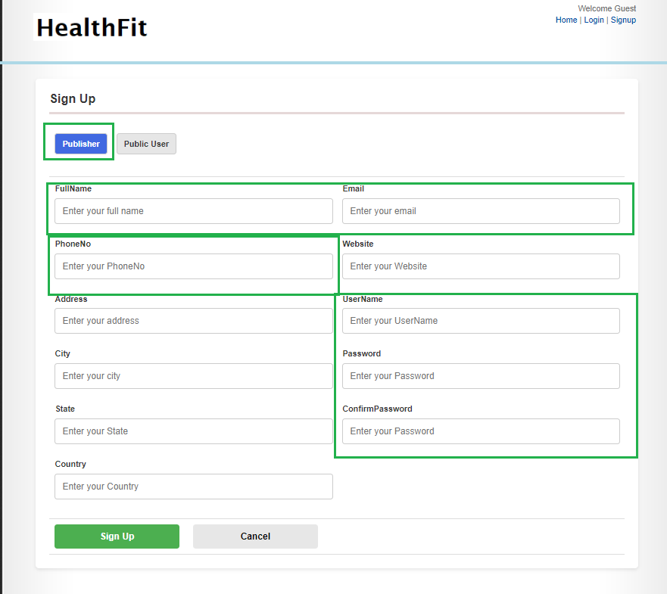
5. Enter required fields and hit the Sign Up button.
6. Publisher has been successfully registered now.
7. In th same way Public user can also register to portal.

**Login (Publisher):**

1. Once use has registered successfully, he can now able to login to system,
2. Click on Login link on right top corner of the page.
3. 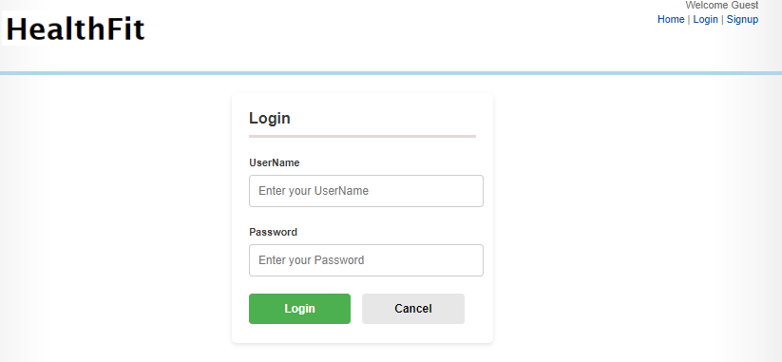
4. Enter the valid credentials and then you will able to login to portal and land to dashboard screen.

**Add Update Delete Journal Records (Publisher User) :**

1. Once user login to system, user will able to add update delete the journals details
2. Click on My Journal Link on right top side of page ,
3. 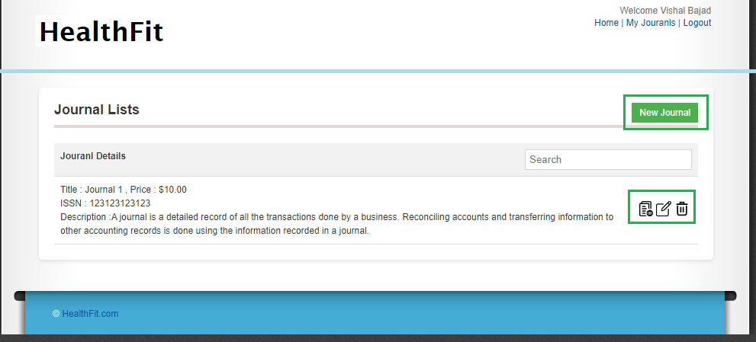
4. Hear you can now add update delete the journal details.
5. For Public user , you can see the View Journal Button only
6. Mandatory Fields on New/Edit Journal page ,
7. 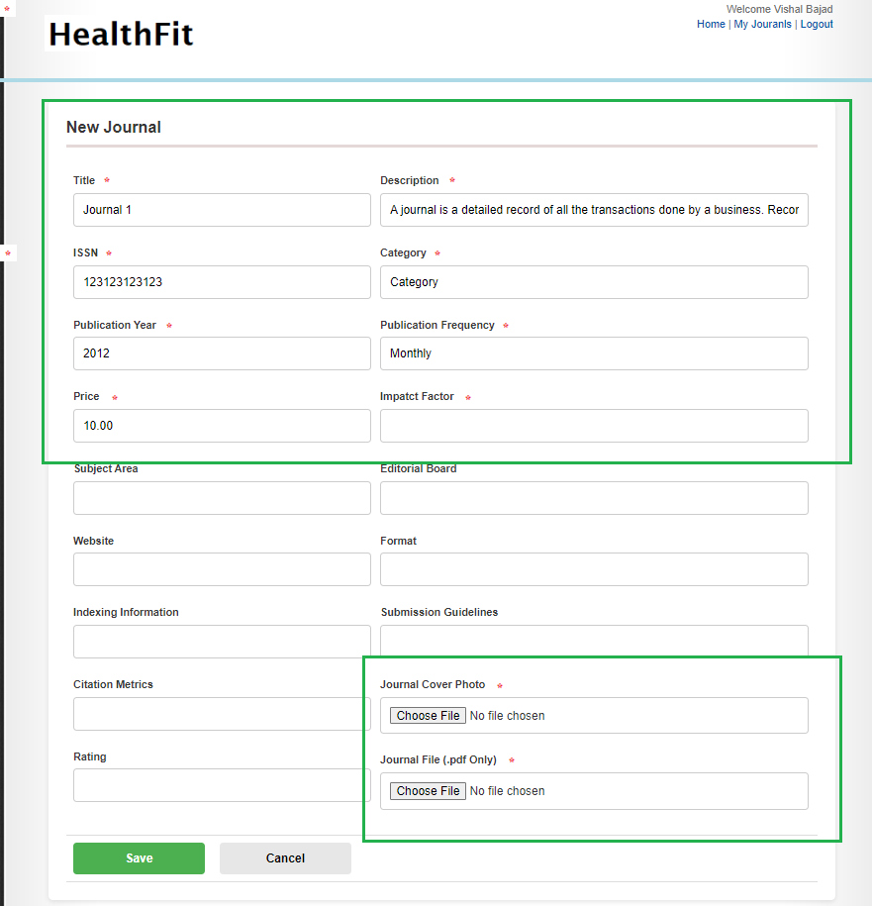
8. After successfully submission, you will redirect to list page.
9. New created journal will start displaying on dashboards and my journal list.

**Details Dashboard View**

In the dashboards you can see the List of journals along with details. you can now search the journal form the available lists



**Journal Details View**

This is details read only view of journal where you can see all details along with cover photo . if you are Publisher then you can see the view journal button to view the journals online. But if you are public user then you can see the buy now buttons. The respective screens are below ,

For Publishers,

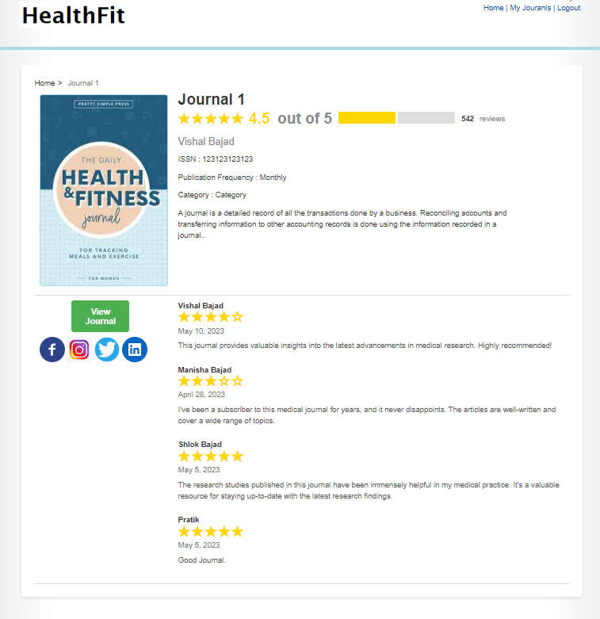

And For Public Users,

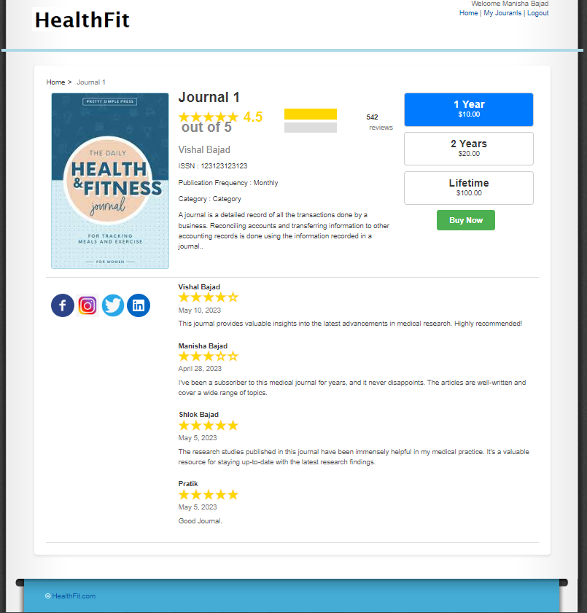

**Journal Read Documents View**

If user has subscribed for journal he can able to read documents online and read documents screen view as below ,

